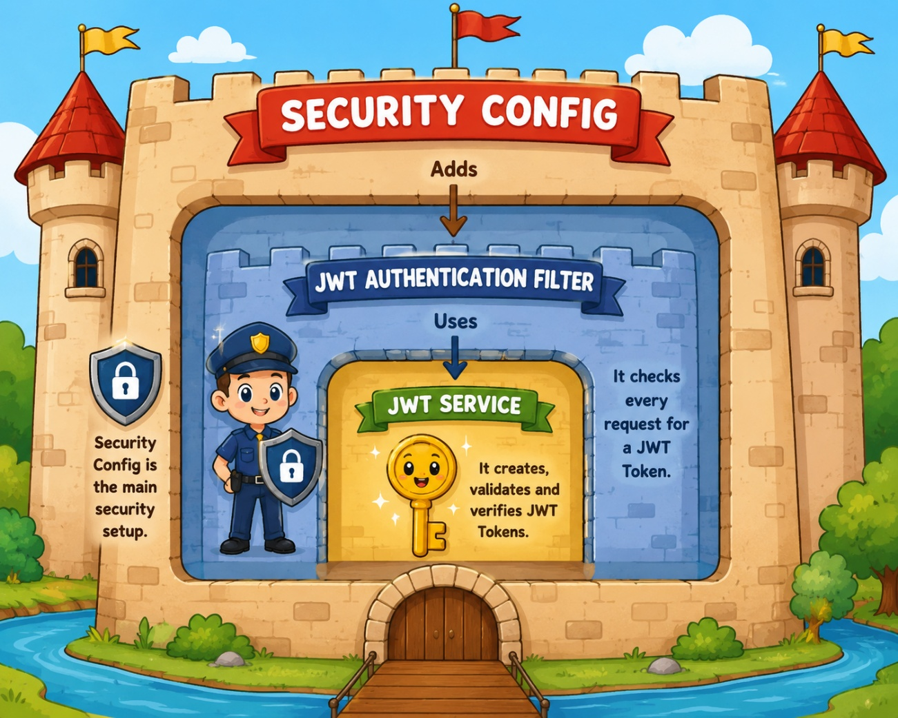

Simple ah

JWT service-create and validate token[also extract info from token]

JWT AF-Request varum bothu token valid ah iruntha email return pannum(for validate we use jwt service) tells Spring Security: "This user is authenticated." ✅

Security Config- Define the security rules
• Configure CORS.
• Decide which URLs are public and which require authentication/roles.

• Add/insert the JWT Authentication Filter into the Spring Security Filter Chain.

🔐 The Proper Function of Each Class

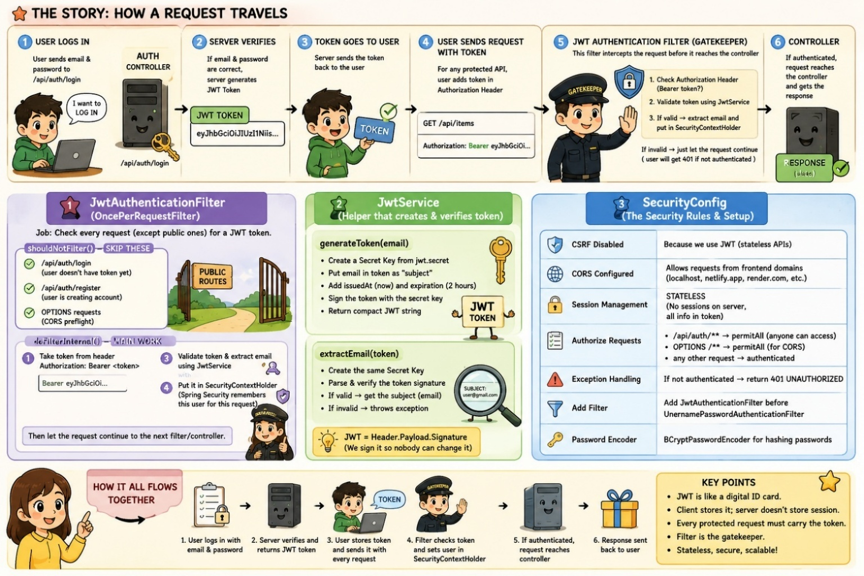
1️⃣ JwtService 🔑 — JWT Token Manager

Main functions:
- ✅ Generate JWT token during login
- ✅ Validate/verify a JWT token
- ✅ Extract user information (email) from the token

Think of it as:
The ID Card Department 🪪 — it creates and verifies digital ID cards.

Used by:
➡️ JwtAuthenticationFilter
JwtService
├── generateToken(email) → Creates JWT
└── extractEmail(token) → Verifies token and gets email

2️⃣ JwtAuthenticationFilter 👮 — JWT Security Guard

Main functions:
- Receives every incoming protected request
- Checks whether an Authorization header exists?
- Extracts the JWT
- Sends the JWT to JwtService
- Gets the user's email if the token is valid
- Creates an authentication object
- Stores it in Spring Security's SecurityContext

Flow:
Incoming Request
↓
JwtAuthenticationFilter 👮
↓
Extract JWT from Authorization header
↓
Uses JwtService 🔑
↓
Validate JWT + Extract Email
↓
Create UsernamePasswordAuthenticationToken 🪪
↓
Store in SecurityContextHolder 🧠

Important correction 🚨
This line is inside your JwtAuthenticationFilter:
new UsernamePasswordAuthenticationToken(...)
So your filter creates the UsernamePasswordAuthenticationToken object.
This object simply tells Spring:
"This user has been authenticated."

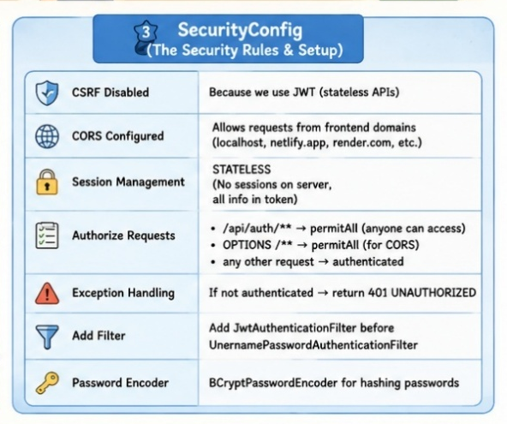
3️⃣ SecurityConfig 🏰 — The Security Manager / Rule Book

Main functions:
- Defines which URLs are public
- Defines which URLs require authentication
- Configures CORS
- Makes authentication stateless
- Adds your JWT filter to Spring Security's filter chain
- Defines what happens when authentication fails

Think of it as:
SecurityConfig doesn't check the JWT itself. It tells Spring Security WHEN and WHERE your JWT security guard should work.

🔗 How Are They Interlinked?
Here is the relationship:
SecurityConfig 🏰
│
│ Adds
▼
JwtAuthenticationFilter 👮
│
│ Uses
▼
JwtService 🔑
So in simple words:
SecurityConfig connects the JWT filter to Spring Security, and the JWT filter uses JwtService to handle the JWT.

Absolutely! 😊 Since you're a beginner, let's understand these three files as one complete story instead of memorizing code line by line.
You have built a JWT-based security system for your Lost & Found Spring Boot application.

🏰 The Big Story: A Secure Building With a Security Guard
Imagine your backend is a secure building.
- 👤 User = Person trying to enter the building
- 🔑 JWT Token = Digital ID card
- 👮 JwtAuthenticationFilter = Security guard at the entrance
- 🧠 JwtService = Machine that creates and verifies ID cards
- 📋 SecurityConfig = The building's security rules
The complete flow is:
User Login
↓
Server verifies username/password
↓
JwtService creates JWT Token 🔑
↓
User stores the token
↓
User sends token with future requests
↓
JwtAuthenticationFilter checks token 👮
↓
If valid → User identity stored in SecurityContext
↓
SecurityConfig allows access 🔓
Let's understand everything slowly.

1️⃣ First, What Is JWT?
JWT stands for JSON Web Token.
After a user logs in successfully, instead of asking for their email and password again and again, the server gives them a special token.
For example:
eyJhbGciOiJIUzI1NiJ9.eyJzdWIiOiJzYWZlZXFAZ21haWwuY29tIn0.xxxxxx
The frontend sends this token with every protected request:
Authorization: Bearer <JWT_TOKEN>
Think of it like this:
You enter an amusement park for the first time and show your ticket. After verification, they give you a wristband. Now, whenever you enter a ride, you show the wristband instead of buying a ticket again.
🎟️ JWT = Wristband

📁 Your Three Files
You have three main classes:
Class | Main Job
JwtService | Creates and reads/verifies JWT tokens
JwtAuthenticationFilter | Checks the token in every incoming request
SecurityConfig | Defines which URLs are public/protected and configures Spring Security
Now let's go one by one.

🔐 PART 1: JwtService — The Token Factory
@Service
public class JwtService {
JwtService is responsible for JWT-related operations.
It mainly does two things:
- ✨ Generate a token
- 🔍 Verify/read a token
@Service tells Spring:
"This class contains business logic. Create and manage an object of it."
So you don't need to manually do:
new JwtService()
Spring does it for you.

🔑 Reading the Secret Key
@Value("${jwt.secret}")
private String secret;
Your JWT needs a secret key.
Usually, in application.properties:
jwt.secret=your-super-secret-key...
Spring takes that value and puts it into:
private String secret;

✨ generateToken() — Creating the Digital ID Card
public String generateToken(String email)
When a user successfully logs in, you call:
jwtService.generateToken(email);
For example:
Email: safeeq@gmail.com
The JWT will contain information about that user.

public String generateToken(String email) {

SecretKey key=Keys.hmacShaKeyFor(
secret.getBytes(StandardCharsets.UTF_8) //cryptographic keys work with bytes.
); //Takes those bytes and creates a proper HMAC secret key

return Jwts.builder()
.subject(email)
.issuedAt(new Date())
.expiration(
new Date(
System.currentTimeMillis()
+1000*60*60*2 //1000 milliseconds = 1 second
)
)
.signWith(key)
.compact();
}

Step 1: Create a SecretKey
SecretKey key=Keys.hmacShaKeyFor(
secret.getBytes(StandardCharsets.UTF_8)
);
Your secret is initially a Java String.
But cryptographic operations work using bytes.
So:
Secret String
↓
Convert to bytes
↓
Create SecretKey
This key is used to sign the token.

Step 2: Build the JWT
return Jwts.builder()
This starts building your token.
Think of it as filling out a digital ID card.

👤 Subject
.subject(email)
The subject represents who this token belongs to.
In your application:
Subject = User's Email
Example:
safeeq@gmail.com
Later, when the token comes back, you can identify the user from this email.

🕒 Issued Time
.issuedAt(new Date())
This stores:
When was this token created?
For example:
Issued at: 23 August 2026, 3:00 PM

⏰ Expiration Time
.expiration(
new Date(
System.currentTimeMillis()
+1000*60*60*2
)
)
Let's break this down:
1000 milliseconds = 1 second
60 seconds = 1 minute
60 minutes = 1 hour
2 hours = Token lifetime
So your token expires after 2 hours.
Why?
Imagine if someone steals a permanent ID card. They could use it forever.
But if the card expires after 2 hours, the damage is limited.

✍️ Sign the Token
.signWith(key)
This is one of the most important parts.
The server digitally signs the token using your secret key.
Conceptually:
JWT Data + Secret Key
↓
Digital Signature
Later:
JWT Token
↓
Verify Signature using Secret Key
↓
Valid or Fake?
If someone changes the email inside the JWT:
safeeq@gmail.com → admin@gmail.com
The signature won't match anymore ❌.

📦 compact()
.compact();
This converts the JWT into its final compact string format that can be sent through HTTP.
So the complete generation flow is:
Email
↓
Add Subject
↓
Add Creation Time
↓
Add Expiration Time
↓
Sign Using Secret Key
↓
Convert to JWT String
↓
Return Token 🔑

🔍 extractEmail() — Checking and Reading the Token

public String extractEmail(String token) {

SecretKey key=Keys.hmacShaKeyFor(
secret.getBytes(StandardCharsets.UTF_8)
);

return Jwts.parser()
.verifyWith(key) //key to verify the JWT's signature.
.build() // Build the JWT parser.
.parseSignedClaims(token) //sign matched amd gives Claims(info in token)
//throws an exception if the token's signature doesn't match the provided key.
.getPayload() //get subject from payload
.getSubject();
}

public String extractEmail(String token)
Whenever a request comes with a token, you want to know:
Who is this user?
That's what this method does.

Step 1: Create the Same Secret Key
SecretKey key=Keys.hmacShaKeyFor(
secret.getBytes(StandardCharsets.UTF_8)
);
You use the same secret key that was used when generating the token.

Step 2: Create a JWT Parser
return Jwts.parser()
The parser is like a token-reading machine.

Verify the Signature
.verifyWith(key)
The parser checks:
Was this token really created using our secret key?
If someone creates a fake token, verification fails ❌.

Build the Parser
.build()
This finalizes the parser configuration.

Parse the Token
.parseSignedClaims(token)
This checks and reads the signed token.
It can detect problems such as:
- ❌ Invalid signature
- ❌ Expired token
- ❌ Malformed token
- ❌ Fake/tampered token
If something is wrong, it throws an exception.

Get the Payload
.getPayload()
A JWT conceptually contains three parts:
HEADER.PAYLOAD.SIGNATURE
The payload contains information such as:
Subject → User Email
Issued Time
Expiration Time

Get the Email
.getSubject();
Because you stored the email as the subject:
.subject(email)
You can retrieve it using:
.getSubject()
So the complete flow is:
JWT Token
↓
Verify Signature
↓
Check Token Validity
↓
Read Payload
↓
Get Subject
↓
Return Email 👤

👮 PART 2: JwtAuthenticationFilter — The Security Guard

package com.example.lostfound.security;

import jakarta.servlet.FilterChain;
import jakarta.servlet.ServletException;
import jakarta.servlet.http.HttpServletRequest;
import jakarta.servlet.http.HttpServletResponse;

import org.springframework.security.authentication.UsernamePasswordAuthenticationToken;
import org.springframework.security.core.context.SecurityContextHolder;
import org.springframework.stereotype.Component;
import org.springframework.web.filter.OncePerRequestFilter;

import java.io.IOException;
import java.util.Collections;

@Component
public class JwtAuthenticationFilter extends OncePerRequestFilter {
private final JwtService jwtService;

public JwtAuthenticationFilter(JwtService jwtService)
{this.jwtService=jwtService;}

//Skip JWT checking
@Override
protected boolean shouldNotFilter(HttpServletRequest request) {

String path=request.getServletPath();

return path.equals("/api/auth/login") //because the user doesn't have a token yet.
|| path.equals("/api/auth/register") //because the user is creating an account.
|| request.getMethod().equalsIgnoreCase("OPTIONS"); //because it is usually a CORS preflight request.
}

//Request varuthu athula irunthu token ah eduthu check panrom
//valid na Security Context Holder la attach panirurom
@Override
protected void doFilterInternal(
HttpServletRequest request,
HttpServletResponse response,
FilterChain filterChain) throws ServletException,IOException {

//Request odaya head la Token edukrom
String authHeader=request.getHeader("Authorization"); //Authorization: Bearer eyJhbGci...

// If Authorization header is missing or doesn't contain "Bearer <token>"
if(authHeader==null || !authHeader.startsWith("Bearer "))
{filterChain.doFilter(request,response); //let request go to next filter
return;//no need to execute below codes
}

String token=authHeader.substring(7); //Remove Bearer

try {
String email=jwtService.extractEmail(token);

UsernamePasswordAuthenticationToken authentication=
new UsernamePasswordAuthenticationToken(
email,
null, // No password/credentials as authentication is already established.
Collections.emptyList() //empty list of authorities/roles for this authentication.
);

SecurityContextHolder.getContext().setAuthentication(authentication);

} catch(Exception e) {
System.out.println( "Invalid JWT token: "+e.getMessage());
}

filterChain.doFilter(request,response);
}
}

Now we come to the most important flow.
@Component
public class JwtAuthenticationFilter extends OncePerRequestFilter {
This class acts as a security guard.
Every request entering your application goes through Spring Security filters.
Your filter asks:
"Do you have a JWT token?"

What is OncePerRequestFilter?
extends OncePerRequestFilter
It means:
Run this filter only once for each HTTP request.
For example:
GET /api/items
Your JWT filter processes it once.
This prevents unnecessary multiple executions for the same request.

@Component
@Component
This tells Spring:
Create and manage an object of this filter.
Now Spring can inject it into your SecurityConfig.

🤝 Constructor Injection
private final JwtService jwtService;
Your filter needs JwtService because it needs to verify and read tokens.
public JwtAuthenticationFilter(JwtService jwtService) {
this.jwtService=jwtService;
}
Spring automatically provides the JwtService object.
So:
JwtAuthenticationFilter
needs
↓
JwtService
↓
Spring connects them automatically
This is called Dependency Injection.

⏭️ shouldNotFilter() — Requests That Don't Need Checking
@Override
protected boolean shouldNotFilter(HttpServletRequest request)
This method decides:
Should I skip JWT checking for this request?

Get the URL
String path=request.getServletPath();
For example:
http://localhost:8080/api/auth/login
The path is:
/api/auth/login

Skip Login
path.equals("/api/auth/login")
Why skip?
Because when the user is trying to log in, they don't have a token yet!
Story:
Security guard asks for an ID card. The person says, "I'm here to get my ID card!" 😂
So login must be allowed without JWT.

Skip Register
path.equals("/api/auth/register")
A new user also doesn't have a token yet.
So registration should be accessible publicly.

Skip OPTIONS
request.getMethod().equalsIgnoreCase("OPTIONS")
Browsers sometimes send an OPTIONS request before the actual request. This is called a CORS preflight request.
Example:
Browser → OPTIONS /api/items
Server → Yes, POST is allowed
Browser → POST /api/items
You don't need JWT authentication for this preflight check.

Important Understanding ⭐
If shouldNotFilter() returns:
true
➡️ JWT filter is skipped.
If it returns:
false
➡️ JWT filter runs normally.

🚪 doFilterInternal() — The Main Security Check
@Override
protected void doFilterInternal(...)
This method contains the actual JWT checking logic.
Let's follow a real request.
Imagine the frontend sends:
GET /api/items

Authorization: Bearer eyJhbGciOi...

Step 1: Get Authorization Header
String authHeader=request.getHeader("Authorization");
This reads:
Authorization: Bearer TOKEN
So:
authHeader = "Bearer eyJhbGciOi..."

Step 2: Check Whether a Token Exists
if(authHeader==null || !authHeader.startsWith("Bearer "))
Two possibilities:

No Authorization header
authHeader == null

Wrong format
Authorization: Token abc
Instead of:
Authorization: Bearer abc
In both cases:
filterChain.doFilter(request,response);
return;
This means:
"I cannot authenticate this user. Continue to the next security check."
⚠️ Very important: This does not automatically give access to the user.
Your SecurityConfig later says:
.anyRequest().authenticated()
So protected requests without authentication will eventually be rejected with 401 Unauthorized.

Step 3: Remove "Bearer "
String token=authHeader.substring(7);
Why 7?
Because:
B e a r e r _
1 2 3 4 5 6 7
The first 7 characters are "Bearer ".
So:
Bearer abcdefgh
↓
substring(7)
↓
abcdefgh
Now you have the actual JWT token.

Step 4: Try to Read the Email
try {
String email=jwtService.extractEmail(token);
This sends the token to JwtService.
Filter
↓
JwtService.extractEmail(token)
↓
Verify Signature
↓
Check Validity
↓
Extract Email
If successful:
email = user@gmail.com


🪪 Creating Spring Security Authentication
UsernamePasswordAuthenticationToken authentication=
new UsernamePasswordAuthenticationToken(
email,
null,
Collections.emptyList()
);
This might sound confusing, but the idea is simple.
You are telling Spring Security:
"I have verified this request. This request belongs to this user."
The three values are:

1. Principal
email
This represents who the user is.
In your project, you are using the email as the identity.

2. Credentials
null
Normally, credentials could be a password.
But the user has already been authenticated using the JWT.
You don't need the password again.

3. Authorities
Collections.emptyList()
Authorities are permissions or roles.
Examples:
ROLE_USER
ROLE_ADMIN
ROLE_MODERATOR
Currently, your application doesn't use roles here, so you provide an empty list.

🧠 SecurityContextHolder — Spring's Temporary Memory
SecurityContextHolder.getContext().setAuthentication(authentication);
This is the key line!
Imagine Spring Security has a temporary notebook for the current request:
CURRENT REQUEST
----------------------
Authenticated User:
Email: user@gmail.com
Authenticated: YES ✅
You are placing the user's identity into that notebook.
This notebook is called the Security Context.
Now other parts of Spring Security know:
"This request has already been authenticated."

❌ What If the Token Is Invalid?
} catch(Exception e) {
System.out.println("Invalid JWT token: "+e.getMessage());
}
If the token is:
- Expired
- Fake
- Modified
- Incorrectly formatted
An exception happens.
Your code catches it and prints:
Invalid JWT token: ...
Most importantly, the user is not added to the SecurityContext.
Therefore, later Spring Security sees:
User authenticated? NO ❌
And if the endpoint is protected:
401 Unauthorized

➡️ Continue the Filter Chain
filterChain.doFilter(request,response);
This means:
"My JWT checking is complete. Continue the request through the remaining filters and eventually to the controller."
Think of an airport:
Security Check 1
↓
Security Check 2
↓
Passport Check
↓
Gate
Spring Security works similarly with multiple filters.

QNA SESSIONS

Q: Why don't we include the password in UsernamePasswordAuthenticationToken?
A: Because the JWT has already been verified using the secret key. We already know the user's identity, so there is no need to check the password again.
new UsernamePasswordAuthenticationToken(
email, // verified user's identity
null, // no password needed
Collections.emptyList()
);

Q: Then why do we put it in SecurityContextHolder?
A: To tell Spring Security:
"This request(only this particular req) is authenticated, and this is the user."
SecurityContextHolder.getContext().setAuthentication(authentication);

Q: What happens when the user logs out?
A: In JWT authentication, the server usually doesn't maintain a session. The frontend deletes the JWT.
Login → JWT created
↓
Request → JWT verified → Authentication → SecurityContextHolder
↓
Request finishes → SecurityContext cleared
↓
Logout → JWT deleted
↓
Future requests → No JWT → Not authenticated
In one line:
JWT proves who you are, Authentication represents who you are, and SecurityContextHolder tells Spring this request is authenticated as that user.

Q: Why is Collections.emptyList() empty?
A: Because in your current code, you are not giving the user any roles/permissions.
Collections.emptyList()
means:
"This authenticated user has no authorities/roles that I want Spring Security to use."

Q: What would we normally put there?
If your application has roles, you could put:
List.of(new SimpleGrantedAuthority("ROLE_USER"))
or:
List.of(ee
new SimpleGrantedAuthority("ROLE_USER"),
new SimpleGrantedAuthority("ROLE_ADMIN")
)
Then:
new UsernamePasswordAuthenticationToken(
email,
null,
List.of(new SimpleGrantedAuthority("ROLE_USER"))
);

Q: When do we use roles?
When you want to restrict certain APIs.
For example:
.requestMatchers("/admin/**").hasRole("ADMIN")
Then only users with:
ROLE_ADMIN
can access /admin/**.

Simple idea
emptyList()
↓
No roles/permissions

ROLE_USER
↓
Normal user permissions

ROLE_ADMIN
↓
Admin permissions
So your project uses emptyList() because you're currently authenticating the user but not assigning any roles/authorities.

Q: Why do we use filterChain.doFilter() in two places?
A: Because there are two situations:

1️⃣ First filterChain.doFilter()
This part:
if(authHeader==null || !authHeader.startsWith("Bearer ")) {
filterChain.doFilter(request,response);
return;
}
Story:
👮 Guard: "Do you have a JWT?" User: ❌ "No."
👮 Guard: "Okay, I won't check your JWT. Continue to the next security check."
That's what:
filterChain.doFilter(request,response);
means.
The return is important because we don't want this filter to continue executing the JWT verification code.
2. JWT exists:
filterChain.doFilter(request,response);
→ JWT was checked, authentication was set, so let the request continue.

Q: What does filterChain.doFilter() basically mean?
A: "My filter's job is done. Let the request move to the next filter/controller."

Q: If filterChain.doFilter() sends the request to the next filter, why do we need return?
A: They do two different things.
filterChain.doFilter(request,response);
return;
- filterChain.doFilter() → sends the request forward to the next filter.
- return → stops your current JWT filter from executing any more code.

Example:
if(noToken) {
filterChain.doFilter(request,response);
return;
}

// JWT verification code
Without return:
No JWT
↓
filterChain.doFilter()
↓
Request goes forward
↓
Then comes BACK to this code
↓
JWT verification code also executes ❌
With return:
No JWT
↓
filterChain.doFilter()
↓
Request goes forward
↓
return
↓
Current filter stops ✅

So remember:
doFilter() = move the request forward
return = stop executing this filter

🏗️ PART 3: SecurityConfig — The Building's Rule Book
Now let's understand the class that controls the entire security system.
@Configuration
public class SecurityConfig {
This class contains your security configuration.
Think of it as a rule book given to all security guards.
It defines:
- Who can enter?
- Which doors are public?
- Which doors need authentication?
- Where should the JWT filter run?
- How should CORS work?
- Should sessions be stored?

package com.example.lostfound.security;

import jakarta.servlet.http.HttpServletResponse;

import org.springframework.context.annotation.Bean;
import org.springframework.context.annotation.Configuration;
import org.springframework.http.HttpMethod;
import org.springframework.security.config.annotation.web.builders.HttpSecurity;
import org.springframework.security.config.http.SessionCreationPolicy;
import org.springframework.security.crypto.bcrypt.BCryptPasswordEncoder;
import org.springframework.security.crypto.password.PasswordEncoder;
import org.springframework.security.web.SecurityFilterChain;
import org.springframework.web.filter.OncePerRequestFilter;

import org.springframework.web.cors.CorsConfiguration;
import org.springframework.web.cors.CorsConfigurationSource;
import org.springframework.web.cors.UrlBasedCorsConfigurationSource;

import java.util.List;

@Configuration
public class SecurityConfig {

private final JwtAuthenticationFilter jwtAuthenticationFilter;

public SecurityConfig(JwtAuthenticationFilter jwtAuthenticationFilter) {
this.jwtAuthenticationFilter=jwtAuthenticationFilter;
}

@Bean
public SecurityFilterChain securityFilterChain(HttpSecurity http) throws Exception {

http
.csrf(csrf -> csrf.disable())

.cors(cors -> cors.configurationSource(corsConfigurationSource()))

.sessionManagement(session -> session
.sessionCreationPolicy(SessionCreationPolicy.STATELESS)
)

.authorizeHttpRequests(auth -> auth

.requestMatchers("/api/auth/**").permitAll()

.requestMatchers(
HttpMethod.OPTIONS,
"/**"
).permitAll()

.anyRequest().authenticated() //Protect Everything Else
)

.exceptionHandling(exception -> exception
.authenticationEntryPoint(
(request,response,authException) -> {
response.setStatus(
HttpServletResponse.SC_UNAUTHORIZED
);
}
)
)

.addFilterBefore(
jwtAuthenticationFilter,
org.springframework.security.web.authentication.UsernamePasswordAuthenticationFilter.class
);

return http.build();
}

@Bean
public CorsConfigurationSource corsConfigurationSource() {

CorsConfiguration configuration=new CorsConfiguration();

configuration.setAllowedOriginPatterns(
List.of(
"http://localhost:5173",
"http://localhost:5174",
"https://*.netlify.app",
"https://lost2found-3l2n.onrender.com"
)
);

configuration.setAllowedMethods(
List.of(
"GET",
"POST",
"PUT",
"DELETE",
"PATCH",
"OPTIONS"
)
);

configuration.setAllowedHeaders(
List.of("*")
);

configuration.setAllowCredentials(true);

UrlBasedCorsConfigurationSource source=
new UrlBasedCorsConfigurationSource();

source.registerCorsConfiguration("/**",configuration);

return source;
}

@Bean
public PasswordEncoder passwordEncoder() {
return new BCryptPasswordEncoder();
}
}

🔌 Getting the JWT Filter
private final JwtAuthenticationFilter jwtAuthenticationFilter;
Your security configuration needs your JWT security guard.

public SecurityConfig(JwtAuthenticationFilter jwtAuthenticationFilter) {
this.jwtAuthenticationFilter=jwtAuthenticationFilter;
}
Again, Spring performs Dependency Injection.
Spring creates JwtAuthenticationFilter
↓
Spring gives it to SecurityConfig


🛡️ SecurityFilterChain= Main security rulebook

This is basically telling the security guard:
:Dei rules follow pannuda
"Here are ALL the rules you must follow."

@Bean
public SecurityFilterChain securityFilterChain(HttpSecurity http)
This is where you define the security rules.
@Bean tells Spring:
"Create this object and use it as part of the application configuration."
The filter chain is basically a sequence of security checks.
Conceptually:
Incoming Request
↓
CORS Check
↓
JWT Filter 👮
↓
Authorization Rules
↓
Controller

❌ CSRF Disabled
.csrf(csrf -> csrf.disable())
CSRF protection is commonly important for applications using traditional session/cookie authentication.
Your application uses:
JWT + Stateless authentication
Therefore, disabling CSRF is commonly used in this type of API setup.

🌍 CORS Configuration
.cors(cors -> cors.configurationSource(corsConfigurationSource()))
CORS stands for Cross-Origin Resource Sharing.
Imagine:
Frontend → http://localhost:5173
Backend → http://localhost:8080
Even though both are on your computer, the browser sees them as different origins.
Without CORS permission, the browser may block the frontend from calling the backend.
Your configuration says:
"Use the rules defined in corsConfigurationSource()."
We'll discuss that shortly.

🚫 STATELESS Session Management
.sessionManagement(session -> session
.sessionCreationPolicy(SessionCreationPolicy.STATELESS)
)
This is very important for JWT.
Traditional login systems work like:
Login
↓
Server creates Session
↓
Server remembers user
JWT works differently:
Login
↓
Server gives Token
↓
Client sends Token every request
The server doesn't need to remember each user session.
That's why:
STATELESS
means:
"Don't create and maintain server-side login sessions."
Every request brings its own proof of identity: the JWT token.

🔓 Authorization Rules
Now we decide who can access what.
.authorizeHttpRequests(auth -> auth
This starts defining URL access rules.

Login and Register Are Public
.requestMatchers("/api/auth/**").permitAll()
Anything starting with:
/api/auth/
is publicly accessible.
Examples:
/api/auth/login
/api/auth/register
/api/auth/forgot-password
permitAll() means:
No authentication required.
⚠️ Notice something interesting: your filter skips only login and register, but SecurityConfig allows all /api/auth/** URLs. If you add more authentication endpoints later, consider whether the filter should also skip them depending on your design.

Allow OPTIONS Requests
.requestMatchers(
HttpMethod.OPTIONS,
"/**"
).permitAll()
This allows all CORS preflight requests.
Again:
OPTIONS → Browser asks permission
Actual Request → Browser sends GET/POST/etc.

Protect Everything Else 🔒
.anyRequest().authenticated()
This is your main protection rule.
It means:
Every other endpoint requires an authenticated user.
For example:
/api/items → JWT required 🔒
/api/items/10 → JWT required 🔒
/api/profile → JWT required 🔒
Without a valid JWT:
401 Unauthorized

🚨 What Happens When Authentication Fails?
.exceptionHandling(exception -> exception
.authenticationEntryPoint(...)
)
This defines what should happen when an unauthenticated person tries to access a protected endpoint.

response.setStatus(
HttpServletResponse.SC_UNAUTHORIZED
);
This sends:
HTTP Status: 401 Unauthorized
Simple meaning:
"You need to log in or provide a valid token."

👮 Adding Your JWT Filter Into Spring Security
.addFilterBefore(
jwtAuthenticationFilter,
UsernamePasswordAuthenticationFilter.class
)
Imagine Spring Security has a security checking queue 🚶:

✅ Actual Concept
Spring Security already has many filters:
Request
↓
[ Spring Security Filter A ]
↓
[ Spring Security Filter B ]
↓
[ UsernamePasswordAuthenticationFilter ]
↓
[ Spring Security Filter C ]
↓
Controller
When you write:
.addFilterBefore(
jwtAuthenticationFilter,
UsernamePasswordAuthenticationFilter.class
)
Spring inserts your filter before the specified filter:
Request
↓
[ Spring Security Filter A ]
↓
[ Spring Security Filter B ]
↓
JwtAuthenticationFilter 👮 ← ADDED
↓
[ UsernamePasswordAuthenticationFilter ]
↓
[ Spring Security Filter C ]
↓
Controller

🌐 CORS Configuration Explained
Now let's understand:
@Bean
public CorsConfigurationSource corsConfigurationSource() {

CorsConfiguration configuration=new CorsConfiguration();
This method creates the CORS rules.

OP MH

Allowed Origins
configuration.setAllowedOriginPatterns(
List.of(
"http://localhost:5173",
"http://localhost:5174",
"https://*.netlify.app",
"https://lost2found-3l2n.onrender.com"
)
);
This defines which frontend websites are allowed to communicate with your backend.
Examples:

Local development
http://localhost:5173
http://localhost:5174
Probably your Vite/React frontend.

Production
https://something.netlify.app
and the specified Render URL.
The backend says:
"I trust requests coming from these origins."

Allowed HTTP Methods
configuration.setAllowedMethods(
List.of(
"GET",
"POST",
"PUT",
"DELETE",
"PATCH",
"OPTIONS"
)
);
These are the operations your frontend is allowed to perform.
Method | Meaning
GET | Read data
POST | Create data
PUT | Replace/update data
PATCH | Partially update data
DELETE | Delete data
OPTIONS | CORS preflight check

Allowed Headers
configuration.setAllowedHeaders(
List.of("*")
);
This means the frontend can send headers.
Most importantly, your JWT needs:
Authorization: Bearer TOKEN
Without allowing the Authorization header, browsers can have CORS problems when sending your JWT.

Allow Credentials
configuration.setAllowCredentials(true);
This allows credential-related cross-origin requests under your configured CORS rules.
For your current setup, remember that CORS and authentication are separate concepts:
- CORS → Can the browser make the request?
- JWT authentication → Is the user allowed to access the protected resource?

Apply CORS Rules Everywhere
source.registerCorsConfiguration("/**",configuration);
This means:
Apply these CORS rules to all URLs in the application.

🔒 PasswordEncoder
@Bean
public PasswordEncoder passwordEncoder() {
return new BCryptPasswordEncoder();
}
This is for passwords, not JWT tokens.
When users register:
Plain Password
↓
BCrypt
↓
Encrypted/Hashed Password
↓
Store in Database
For example:
hello123
should not be stored directly in the database.
Instead, BCrypt creates something like:
$2a$10$....
During login:
User enters password
↓
BCrypt compares it with stored hash
↓
Match? → Login successful
⚠️ Important: BCrypt is a password hashing algorithm, not JWT encryption.

🎬 COMPLETE REAL-LIFE FLOW: LOGIN
Let's imagine a user logs in.

Step 1: User sends login request
POST /api/auth/login

Email: user@gmail.com
Password: password123

Step 2: Login endpoint is public
Because:
.requestMatchers("/api/auth/**").permitAll()
The request can enter without a JWT.

Step 3: Password is verified
Your authentication/login service checks the password using BCrypt.

Step 4: JWT is created
jwtService.generateToken(email);
The token contains:
User Email
Issued Time
Expiration Time
Digital Signature

Step 5: Token returned to frontend
{
"token":"eyJhbGciOi..."
}

🎬 COMPLETE REAL-LIFE FLOW: ACCESSING A PROTECTED API
Now the user wants to view lost items.
GET /api/items
The frontend sends:
Authorization: Bearer eyJhbGciOi...
Now watch the complete journey! 🚀
REQUEST ARRIVES
↓
┌─────────────────────┐
│ SecurityConfig │
│ Security Rules │
└──────────┬──────────┘
↓
┌─────────────────────┐
│ JwtAuthentication │
│ Filter 👮 │
└──────────┬──────────┘
↓
Read Authorization
↓
"Bearer TOKEN"
↓
Remove "Bearer "
↓
Send Token to
JwtService
↓
┌─────────────────────┐
│ Verify Signature 🔐 │
│ Check Expiration ⏰ │
└──────────┬──────────┘
↓
VALID?
↙ ↘
YES NO
↓ ↓
Extract Email No User
↓ ↓
SecurityContext Protected API
gets Authentication ↓
↓ 401 ❌
User is known
↓
.authenticated() passes
↓
Controller 🎉
↓
Response sent

🧠 THE MOST IMPORTANT CONCEPT: SecurityContext
As a beginner, remember this one strongly.
JWT itself does not automatically authenticate the user in Spring.
Your filter does this:
JWT Token
↓
Verify Token
↓
Extract User Identity
↓
Create Authentication Object
↓
Put it into SecurityContext
This line:
SecurityContextHolder.getContext().setAuthentication(authentication);
is basically telling Spring:
"Hey Spring, this request belongs to this authenticated user."
Then Spring can allow access to:
.anyRequest().authenticated()

🔄 All Three Classes Working Together

JwtService 🔑
Question: How do I create and verify tokens?
Generate Token
Extract Email
Verify Signature
Check Expiration

JwtAuthenticationFilter 👮
Question: How do I check every incoming request?
Get Request
↓
Find Authorization Header
↓
Get Token
↓
Ask JwtService to verify
↓
Put User into SecurityContext

SecurityConfig 🏰
Question: What are the security rules?
Public URLs → Allow
Protected URLs → Require authentication
JWT Filter → Add to Security Chain
Sessions → Stateless
CORS → Configure frontend access
Passwords → BCrypt

📚 SUPER SHORT REVISION NOTES

JWT
A digital token used to identify a logged-in user without storing a server-side session.

JwtService
Creates JWT tokens and verifies/reads information from them.

JwtAuthenticationFilter
Intercepts requests, extracts the JWT, validates it, and tells Spring who the user is.

SecurityContext
Spring Security's storage for the currently authenticated user during a request.

SecurityConfig
Defines security rules, protected endpoints, CORS, sessions, and filter configuration.

STATELESS
The server doesn't remember login sessions; the client sends the JWT with every request.

permitAll()
Anyone can access the endpoint.

authenticated()
Only a request with valid authentication can access the endpoint.

401 Unauthorized
The user is not authenticated or doesn't have valid authentication.

BCrypt
Securely hashes passwords before storing them.

⭐ One-Line Story to Remember Everything
The user logs in → JwtService gives them a signed digital ID card → On every future request JwtAuthenticationFilter checks that card → If valid, it puts the user's identity into Spring Security's SecurityContext → SecurityConfig checks the rules and allows the user into protected APIs.
That's the entire architecture of your JWT security system! 🎯
Once you understand this flow, don't try to memorize every line. Always remember the journey of the request—that is the real key to understanding Spring Security. 🔐🚀

